The Production of the Selfie
A
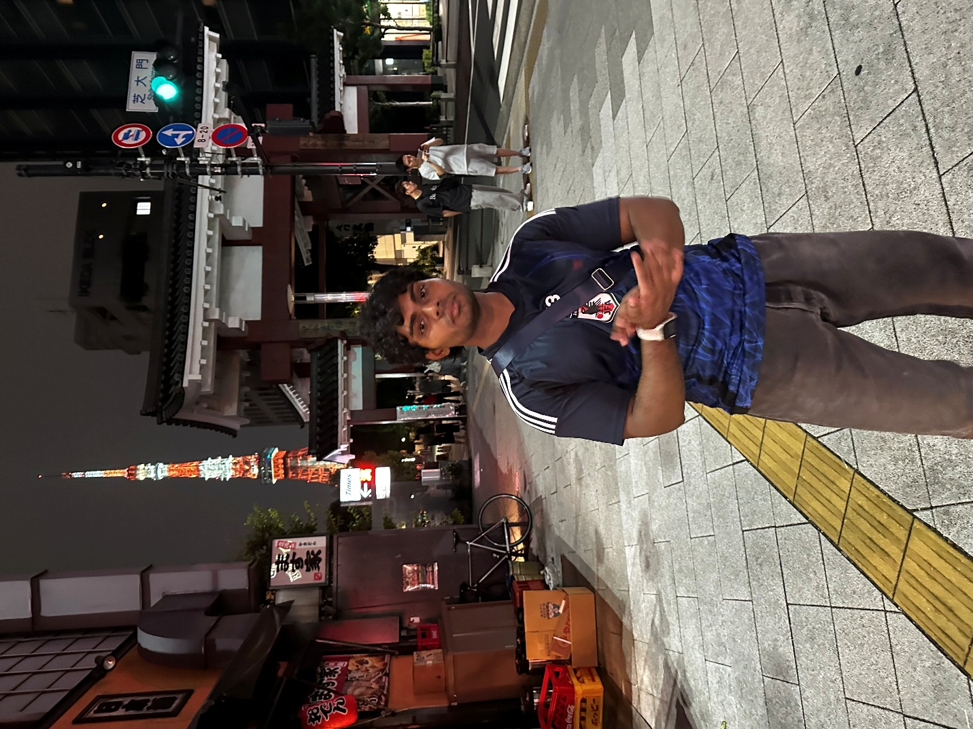
This would be Facebook because it was taken in Japan in front of their, arguably, most iconic scene. Since I want to show the world of fun side of life, I think having this for social media account isn’t a bad idea.

B
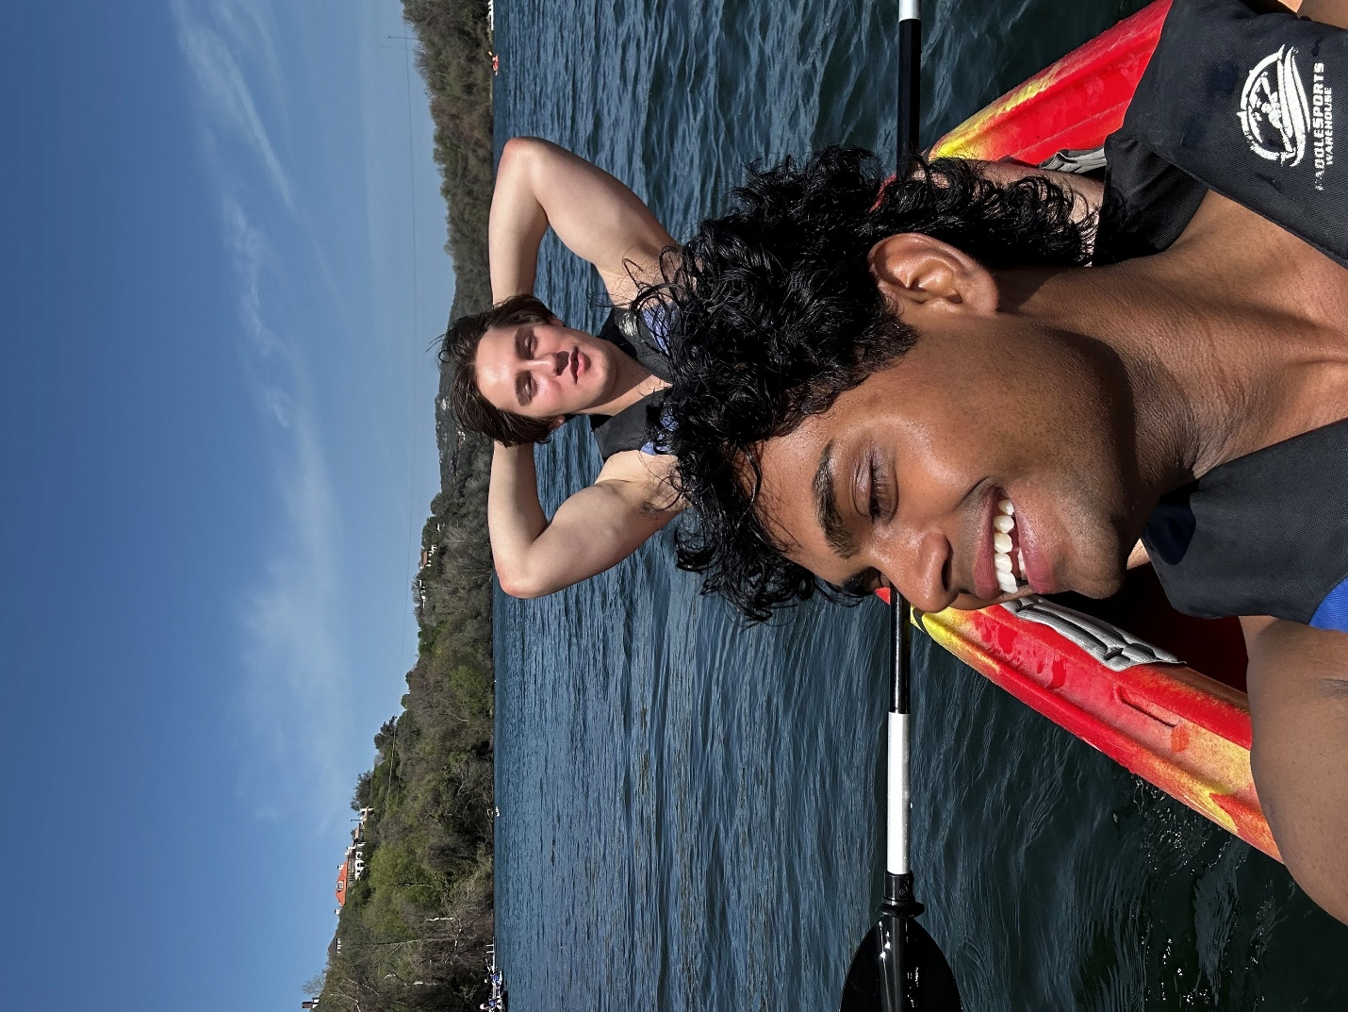
This would be for the band profile since it includes my best friend in the picture. If I were to start a band, I am 100% sure I would start with him since we have known each other for almost a decade.

C
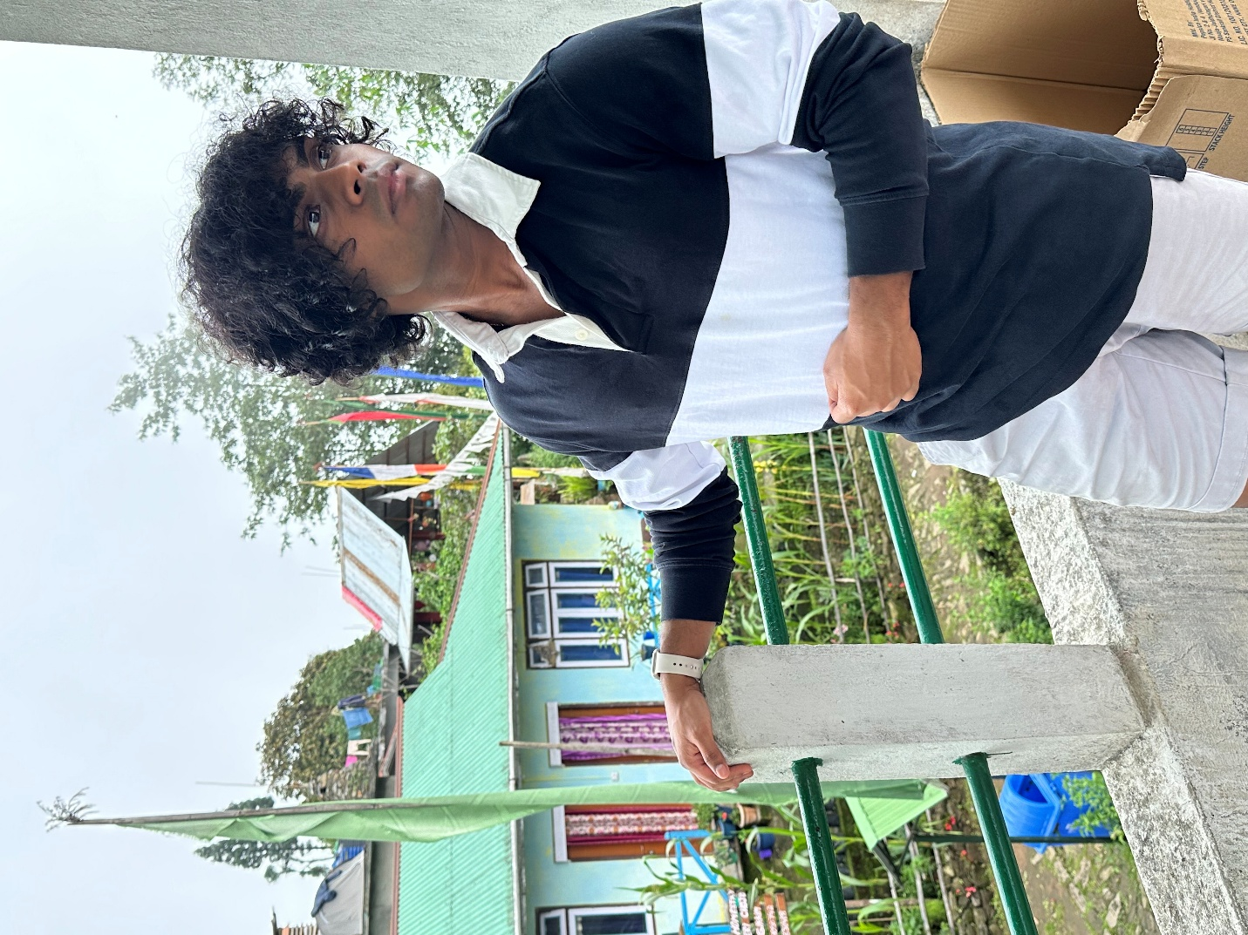
This would be for the company picture since it’s the only one with a proper shirt and no-nonsense things in the picture. Practically the only reason I chose it is because it has a collared shirt.

D
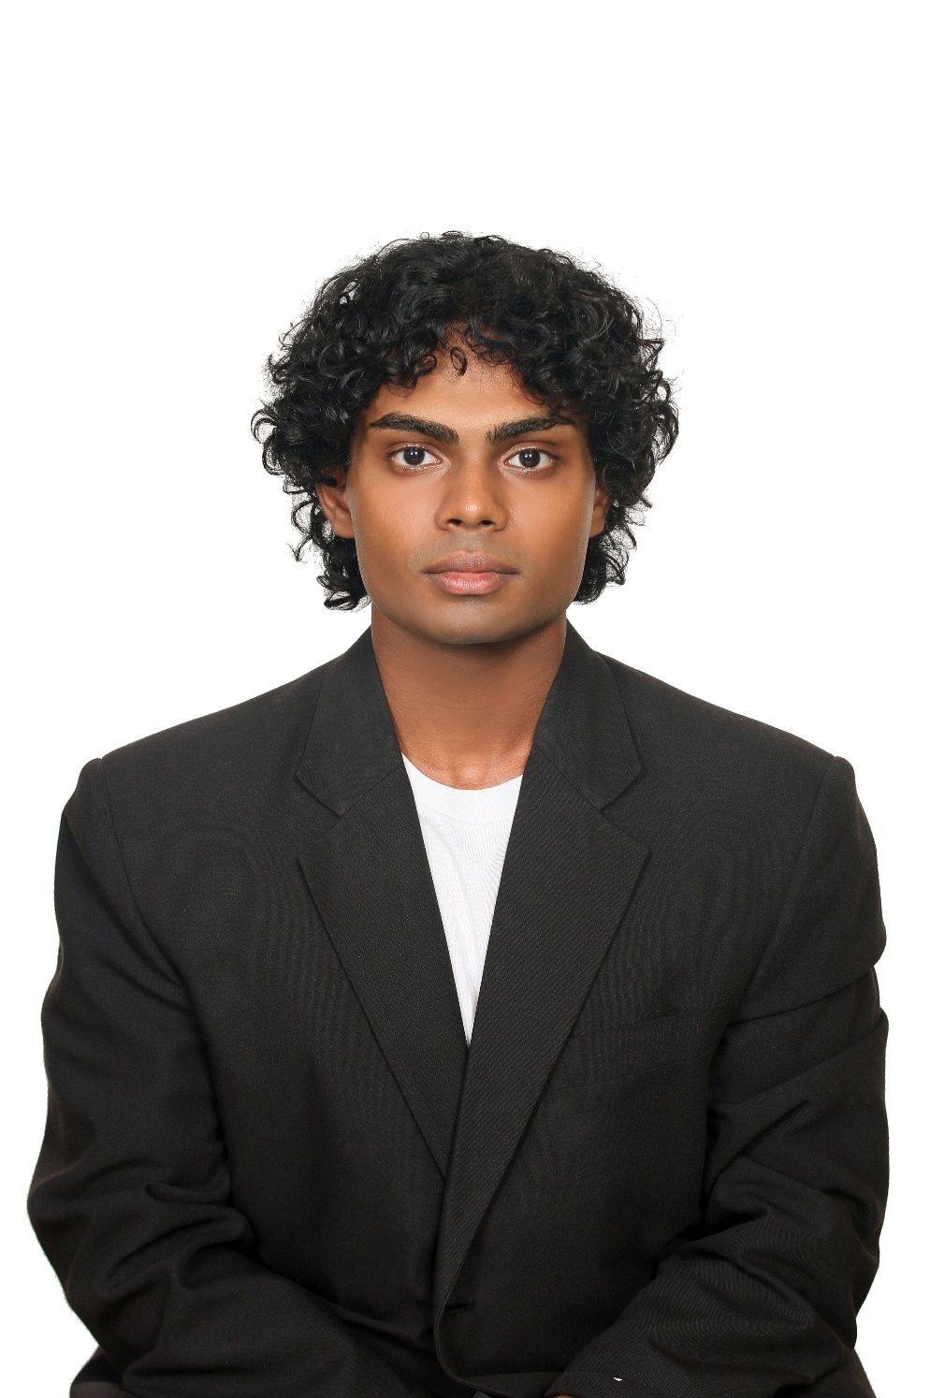
I think this can be used for yearbook pictures since it looks like I graduated. This is from the time I needed to take passport picture in Korea. This maybe be also used for the company picture as it’s professional.

E
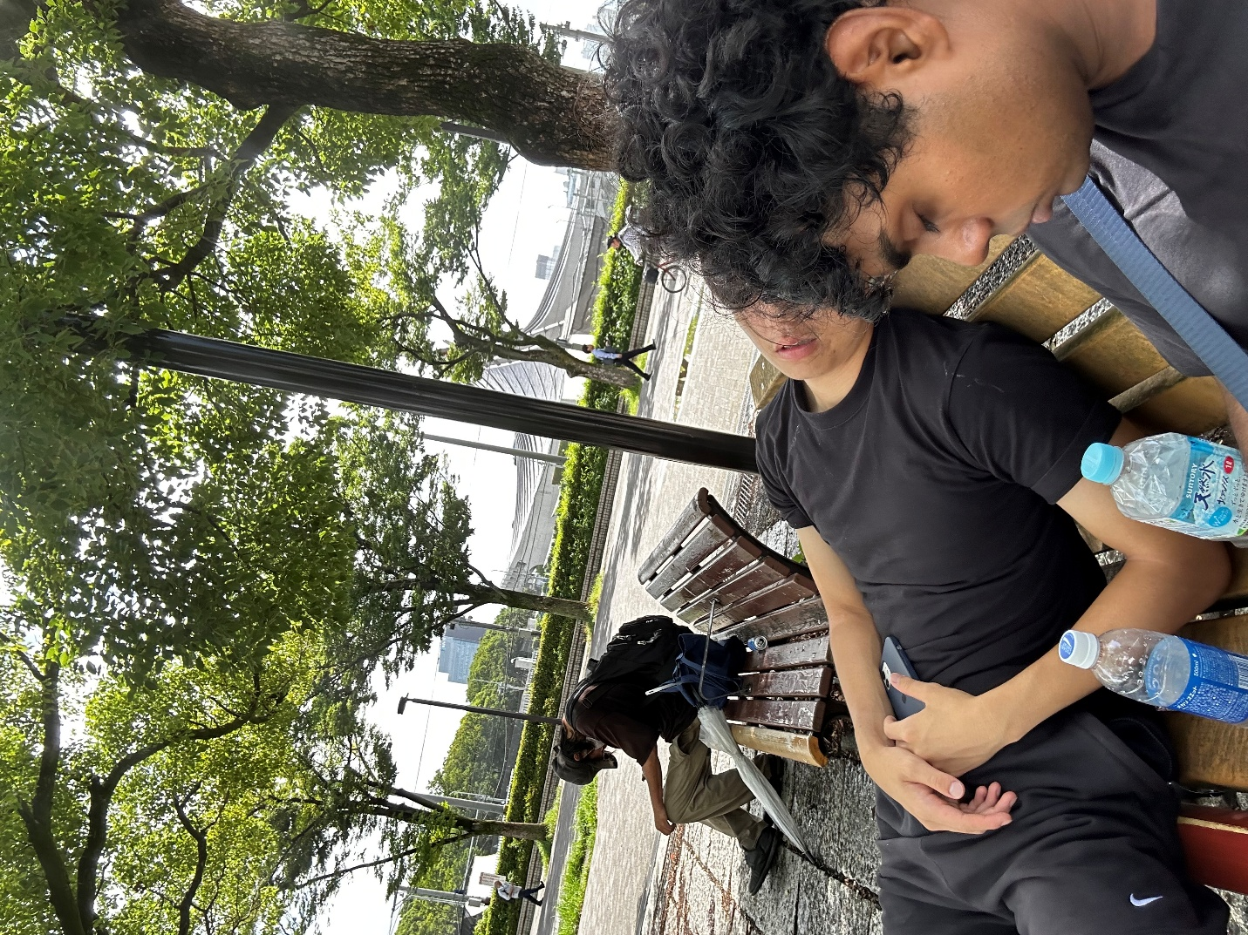
Generally, I don’t take too many photos but when I do, there is something happening in the photo. And this would be what I imagine my daily life to be in Japan. Just work hard then go to a bar and drink a lot and sleep at a park bench then repeat.

F
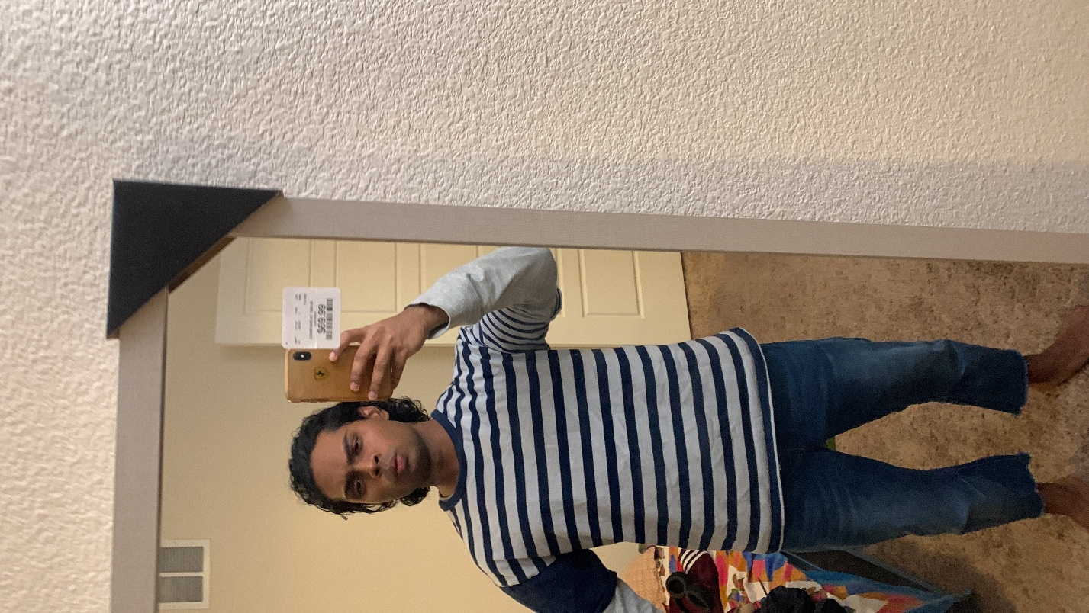
Definitely a Facebook picture just because of how goofy it looks. This was during my long hair time and I think I had just came home and took a pic because I thought “I looked good”.

